**APA 7th SUMMARY**

**APA** (the American Psychological Association) style is a writing style and format for academicdocuments such as scholarly journal articles and books, and is commonly used for citing sources within the field of social sciences.

**Headings:**

|  |  |
| --- | --- |
| Level 1 | **Centered, Bold, Title Case Heading**  Text starts a new paragraph. |
| Level 2 | **Flush left, Bold, Title Case Heading** Text starts a new paragraph. |
| Level 3 | ***Flush Left, Bold Italic, Title Case Heading*** Text starts a new paragraph. |
| Level 4 | I**ndented, Bold Title Case Heading Ending With a Period.** Paragraph text  continues on the same line as the same paragraph. |
| Level 5 | ***Indented, Bold Italic, Title Case Heading Ending With a Period.*** Paragraph text  continues on the same line as the same paragraph. |

*.*

**Title Page**

The title page should contain the **title** of the paper, the **author's name**, and the **institutional affiliation**. A professional paper should also include the **author note**.

The title should be centered and written in **boldface**. All text on the title page, and throughout your paper, should be double-spaced.

***Note:*** *APA 7 provides slightly different directions for formatting the title pages of professional papers (e.g., those intended for scholarly publication) and student papers (e.g., those turned in for credit in a high school or college course).*

**Running Head** Running heads are no longer required for student papers.

Professional papers include a running head on every page, including the title page. However, the “Running head:” label used in the sixth edition is no longer used.

The running head is written in all capital letters. The running head should either be identical to the paper’s title, or a shortened form of the title that conveys the same idea. However, running heads should not exceed 50 characters (including spaces and punctuation).

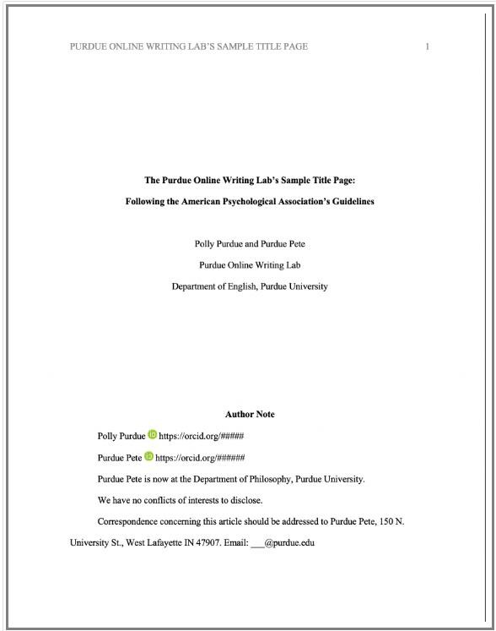

**Abstract** – is a brief, comprehensive summary of the content of the paper. While the official manualspecifics how to write it, it also mentions that not all academic papers might need it (without further explanations on the circumstances when we can skip it), thus, <https://guruassignments.com/> **sets the rule that the** **abstract is an obligatory part of the assignment that is presupposed for publishing: all articles + dissertations (if we provide a complete product) + research papers on social sciences and psychology (longer than 4 pages).**

An abstract is located right after the title page on a separate page, the title “Abstract” is centered and capitalized, **bolded,** the first word of the abstract is not intended. Usually this part is about 150-250 words long and ends with key words in format: “*Keywords*: APA, formatting, style” Abstract is not counted into the general word count.

**Margins.** Leave uniform margins of at least 1 in. (2.54 cm) at the top, bottom, left, and right ofevery page. Combined with a uniform typeface and font size, uniform margins enhance readability and provide a consistent gauge for estimating article length.

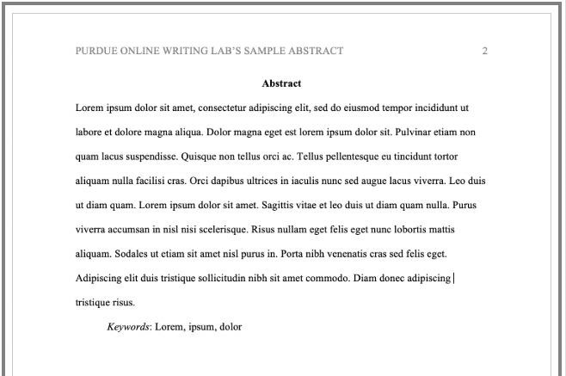

**Referencing and Citations**

**Citations:**

General rule is (Surname, year of publication) or (Surname, the year of publication, p 1) if citing a direct quote.

|  |  |  |  |  |
| --- | --- | --- | --- | --- |
| **Type of citation** | **First citation in** | **Subsequent** | **Parenthetical** | **Parenthetical** |
|  | **text** | **citation in text** | **format, first** | **format,** |
|  |  |  | **citations in text** | **subsequent** **citations in text** |
| One work by **one** author | Walker (2007) | Walker (2007) | (Walker, 2007) | (Walker, 2007) |
| One work by **two** | Walker and Allen | Walker and Allen | (Walker & Allen, | (Walker & Allen, |
| authors | (2007) | (2007) | 2007) | 2007) |
| One work by | Bradley et al. (1999) | Bradley et al. | (Bradley et al.,  1999) | (Bradley et al., |
| **three-five** authors |  | (1999) |  | 1999) |
| One work by **six** | Wasserstein et al. | Wasserstein et al. | (Wasserstejn et | (Wasserstejn et |
| **+** authors | (2005) | (2005) | al., 2005) | al., 2005) |
| Groups (readily | National Institute | NIMH (2003) | (National Institute | (NIMH, 2003) |
| identified through | of Mental |  | of Mental |  |
| abbreviation) as | Health (NIMH, |  | Health [NIMH], |  |
| authors | 2003) |  | 2003) |  |
| Groups (no | University of | University of | (University of | (University of |
| abbreviation) as authors | Pittsburgh (2005) | Pittsburgh (2005) | Pittsburgh, 2005) | Pittsburgh, 2005) |

* When a work's author is designated as "**Anonymous**," cite in Anonymous followed text the word by a comma and the date: (Anonymous, 1998).
* List two or more works by different authors who are cited within the same parentheses in alphabetical order by the first author's surname. Separate the citations with semicolons.
* When a work has **no identified author**, cite in text the first few words of the reference list entry (usually the title) and the year. *Use double quotation marks around the title of an* *article, a chapter, or a web page and italicize the title of a periodical, a book, a brochure, or a report:* on free care ("Study Finds," 2007) the book *College Bound Seniors* (2008)

**NOTE:** Regardless of the medium of the source, all sources with three authors or more are now attributed using the name of the first author followed by “et al.”

*The only exception to this occurs when doing so would create ambiguity (e.g., if two papers have first-listed authors with the same name). In these cases, list as many names as needed to differentiate the papers, followed by “et al.”*

* Example: Fannon, Chan, Ramirez, Johnson, and Grimsdottir (2019) and Fannon, Chan, Montego, Daniels, and Miller (2019) can be cited as (Fannon, Chan, Ramirez, et al., 2019) and (Fannon, Chan, Montego, et al., 2019), respectively.

How to title/cite Tables and Figures Table 1

*Table Title*

|  |  |  |  |  |
| --- | --- | --- | --- | --- |
| Column Head | Column Head | Column Head | Column Head | Column Head |
| Row Head | 123 | 123 | 123 | 123 |
| Row Head | 456 | 456 | 456 | 456 |
| Row Head | 789 | 789 | 789 | 789 |
| Row Head | 123 | 123 | 123 | 123 |
| Row Head | 456 | 456 | 456 | 456 |
| Row Head | 789 | 789 | 789 | 789 |

*Note*: Start a new page for each table, include a table number and table title for each, as shown on thispage. All explanatory text appears in a table note that follows the table, such as this one. Tables in APA format can use single or 1.5 line spacing. Cite the table like this: “Adapted from "Traditions and Alcohol Use: A Mixed-Methods Analysis," by F. C. Castro and K. Coe, 2007, *Cultural Diversity and*

*Ethnic Minority Psychology*, 13, p. 276. Copyright 2007 by the American Psychological Association”.

In APA 7th, tables and figures may now be presented either in the text of the document or after the reference list on separate pages.

Figures title:

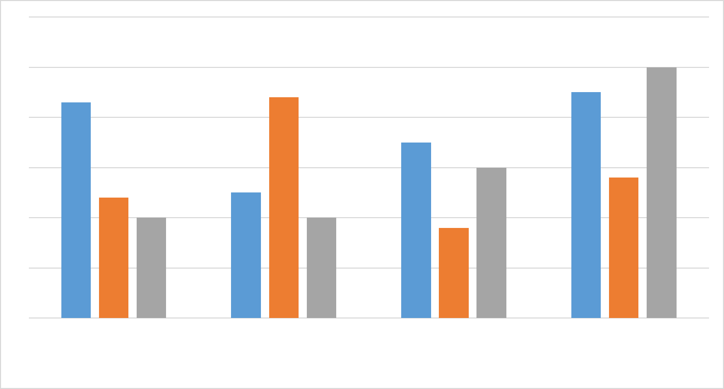

6

5

4

3

2

1

0

Category 1

Category 2

Category 3

Category 4

Series 1

Series 2

Series 3



*Figure 1*. [Include all figures in their own section, following references (and footnotes and tables, ifapplicable). Include a numbered caption for each figure. Cite like this: “Adapted from "Visual Experience Enhances Infants' Use of Task-Relevant Information in an Action Task," by S-h. Wang and L. Kohne, 2007, *Developmental Psychology*, 43, p. 1515. Copyright 2003 by the American

Psychological Association.”

**References:**

Your references should begin on a new page separate from the text of the essay; label this page

"

**References**

" in

**bol**

**d**

, centered at the top of the page (do NOT underline or use quotation marks for the

title).

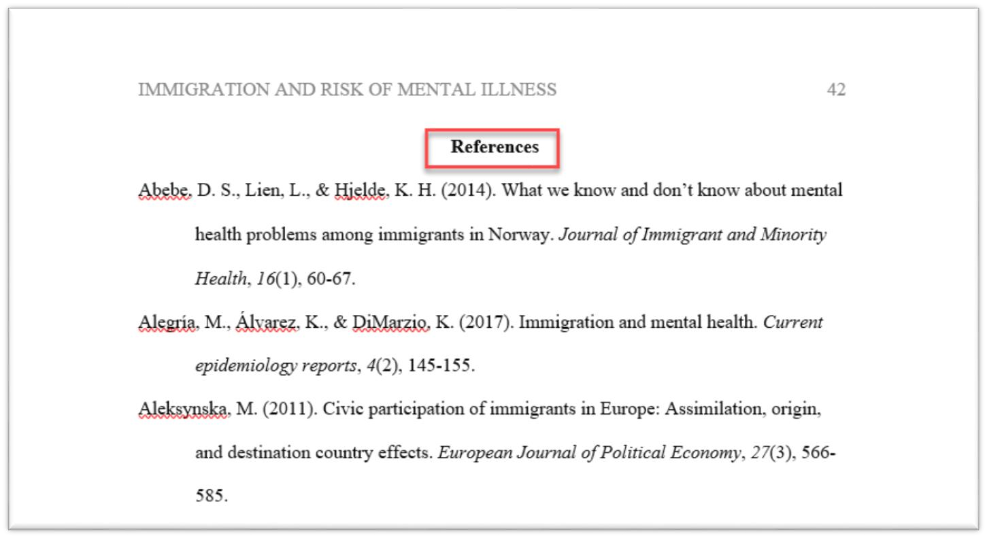

* APA Style generally requires reference lists.
* The reference list must be double-spaced and that entries have a hanging indent.
* Arrange entries in alphabetical order by the surname of the first author followed by initials of the author's given name.
* In general, a reference should contain the author name, date of publication, title of the work, and publication data.
* In the seventh edition, up to 20 authors should now be included in a reference list entry. For sources with more than 20 authors, after the 19th listed author, any additional authors' names are replaced with an ellipsis (…) followed by the final listed author's name. Do not place an ampersand before the final author's name.
* For a book with no editor, simply include the word *In* before the book title.

**Journals, magazines, newspapers, and newsletters**.

Author, A. A., Author, B. B., & Author, C. C. (year). Title of article. *Title of Periodical*, *volume* *number*, pp—pp. http://dx.doi.org/10.1037/pspa0000166

**Or**

Author, A. A., Author, B. B., & Author, C. C. (year). Title of article. *Title of Periodical*, *volume* *number*, pp—pp.

**Or**

Author, A.A., Author, B. P., Author, E., Author, D. C., Author, E., Author, R., Author, R., Author, R., Author, D., Author, Y., Li, W., Author, E., Author, H., Author, J., Author, E. J., Author, N. P., Author, D., Author, J., Author, R., . . . Author, H. (2019). Title of article. *Title of Periodical*, *volume* *number*, pp—pp.<https://doi.org/10.1175/BAMS-D-18-0270.1>**(if** **there are more than 20**  **authors)**

**Book.**

**Entire book:**

Author, A. A. (1967). *Title of work*. Publisher.

**Part of the book:**

Author, A. A., & Author, B. B. (1995). Title of chapter or entry. In A. Editor, B. Editor, & C. Editor (Eds.), *Title of book* (pp. xxx—xxx). Publisher.

**Symposium:**

Contributor, A. A., Contributor, B. B., Contributor, C. C., & Contributor, D. 0. (Year, Month). Title of contribution. In F. E. Chairperson (Chair), *Title of symposium.* Symposium conducted at the meeting of Organization Name, Location.

**Conference:**

Conference paper abstract retrieved online Liu, 5. (2005, May). *Defending against business crises with* *the he/p of intelligent agent based early warning solutions.* Paper presented at the SeventhInternational Conference on Enterprise Information Systems, Miami, FL. Abstract retrieved from

**Dissertations/Theses:**

Lastname, F.M. (Year). *Title of dissertation/thesis* (Publication No.) [Doctoral dissertation/Master’s thesis, Name of Institution Awarding the Degree]. Database or Archive Name.

**Or**

Lastname, F.M. (Year). *Title of dissertation/thesis* [Unpublished doctoral dissertation/master’s thesis]. Name of Institution Awarding the Degree. **(if the work is unpublished)**

**Audiovisual media:**

**Film or Video:**

Director, D. D. (Director). (Date of publication). *Title of motion picture* [Film]. Production company.

**Music recording:**

Recording artist (Year of release). Title of song [Song]. On *Title of album* [Album]. Record label.

**Webpage or Piece of Online Content****:**

Lastname, F. M. (Year, Month Date). *Title of page*. Site name. URL

**Footnotes:**

APA official manual specifies only the use of footnotes for clarifications in the content or copyright permission (if using more than 500 words from the original source).

**Thus,** [**https://guruassignments.com/**](https://guruassignments.com/)**recommends our writers and editors to use footnote/endnote style borrowed from Chicago formatting style**.